**Setup**

1. Extract contents of zip file to a location of your choice
2. Right-click **RunProgram.cmd** and select **Edit**
   1. Change the first file location that is in quotations to your specific **Rscript.exe** location (this is where base R was installed on your machine)
   2. Change the second file location to the location of **run.R** (this is located in the **shiny** folder of the extracted files)

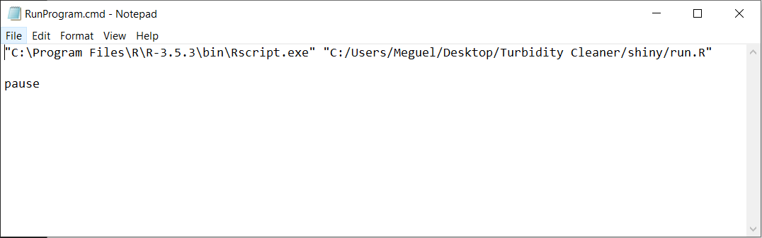**NOTE: The first file location requires back-slash (\) separators and the second file location requires forward-slash (/) separators. Example of my file is shown below**

1. Open **run.R** and change the variable **MainLocation** to the path that the files were extracted to (exact same as the second file location from earlier, without “shiny/run.R”)

**Note: ensure there is a forward-slash at the end of the file location. Example is shown below**

1. Save the file

**Level 1 to Level 2**

1. 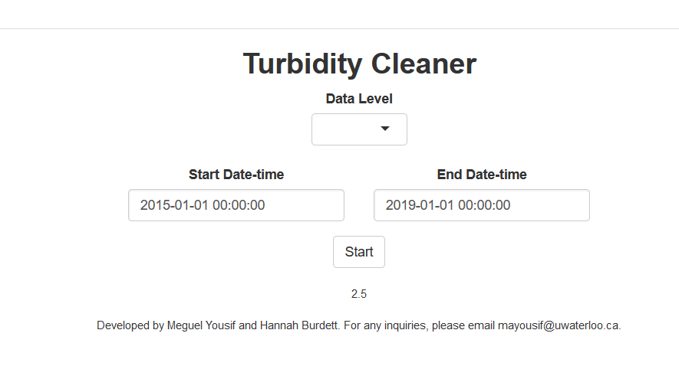Open **RunProgram.cmd**. This should open the following (if not, something was done wrong during setup, refer to the error message in the command window to isolate the issue):
2. Select **1** for the **Data Level**
3. A prompt for the level 1 data file should appear, click **Browse** and find and select the level 1 turbidity data (**LVL1.csv**)
4. Change the **Start Date-time** to 2015-08-01 00:00:00, then click **Start**
5. A new window should appear, though all that is required is to click the **Run** button
6. Once the script finishes, click the **Save** button. This will save a file (**LVL2.csv**) to **MainLocation** (specified during setup)

**Level 2 to Level 3**

1. Open **RunProgram.cmd**
2. Select **Data Level 2**, find and select all required files and datetimes, then click **Start**
3. Use buttons/sliders on the left panel to navigate through the data. Yellow/green data is raw data, black/grey is the currently accepted data. Refer to video example
   1. If a section of data is determined to be erroneous, highlight the section by dragging across the plot, select **1 – To be modelled** for the **Section Type** and click **Mark Section**
   2. If a section is determined to have been incorrectly removed, highlight the section, select **2 – Replace with original**, and click **Mark Section**
4. Once complete, click **Save**. This will save a file (**LVL3.csv**) to **MainLocation**

**Level 3 to Level 4**

1. Open **RunProgram.cmd**
2. Select **Data Level 3**, find and select all required files and datetimes, then click **Start**
3. Click **Run**, wait for the modelling to finish (can take a very long time depending on your machine), and once complete, click **Save** (this will save a file (**LVL4.csv**) to **MainLocation**)